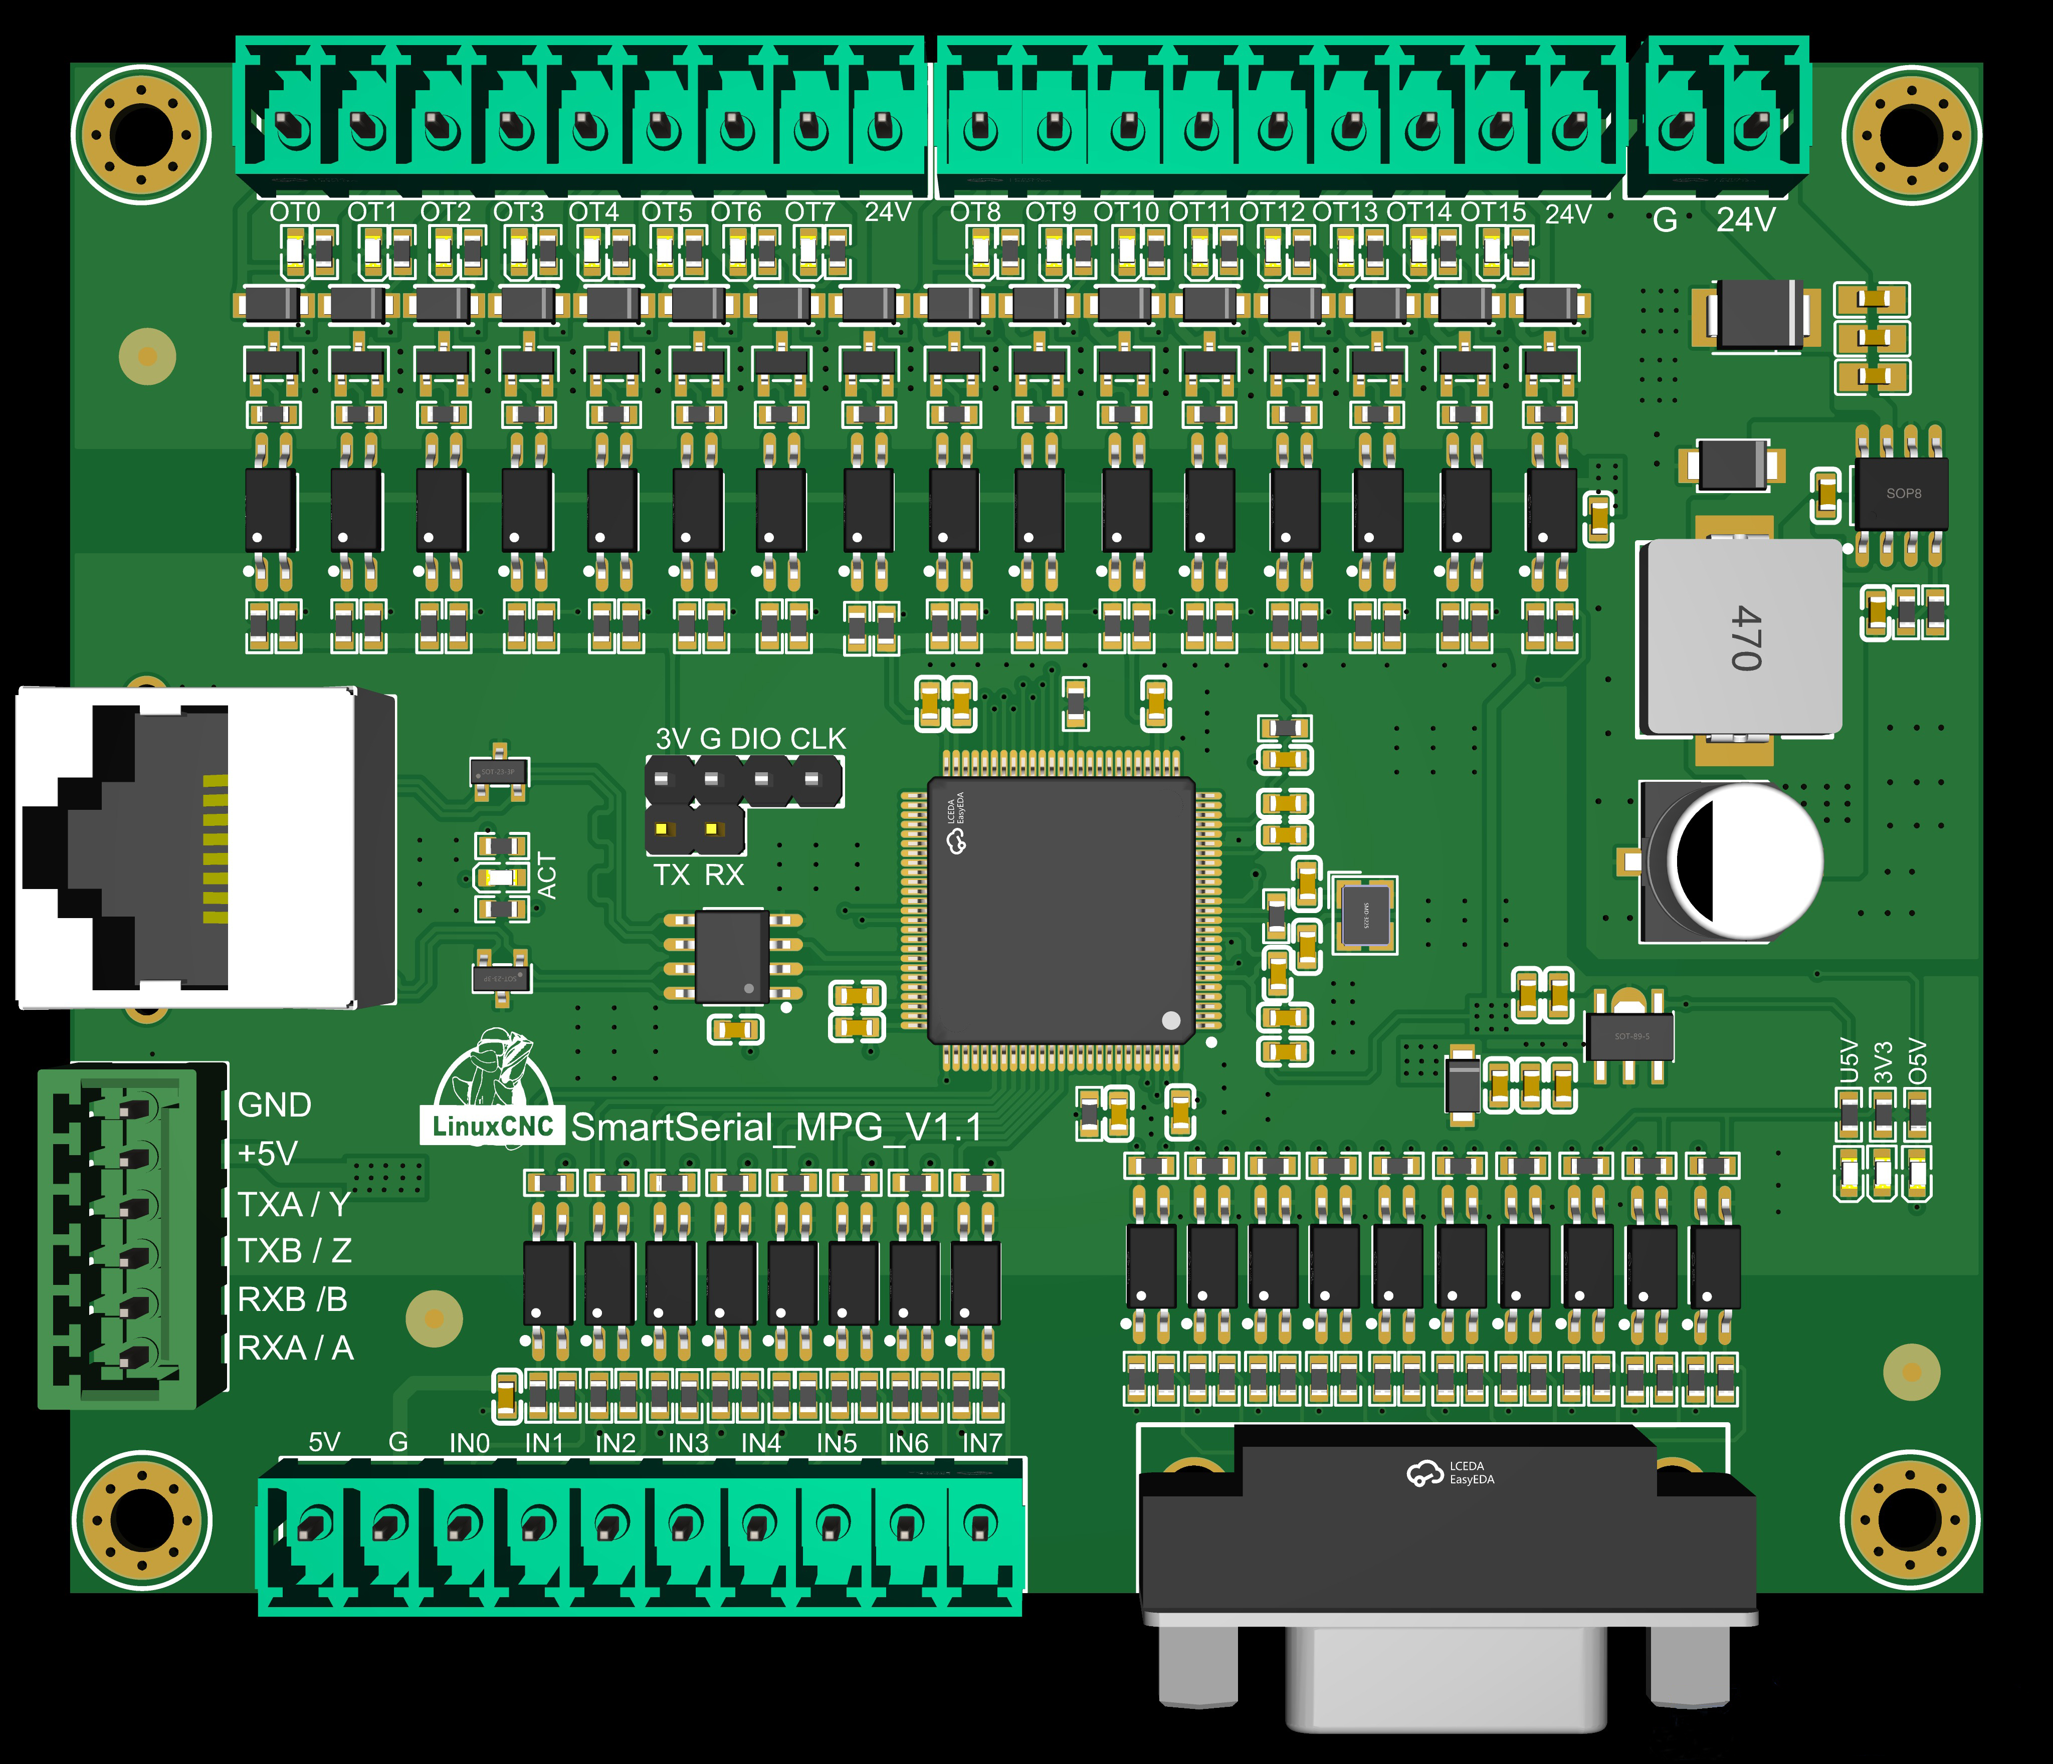

Note: This expansion card can work when inserted into either Smart Serial Port 0 or Smart Serial Port 1.

1. Project Overview
1.1 Application Purpose
This firmware runs on the STM32F407VET6 microcontroller and acts as a slave device for the Mesa SmartSerial protocol. It provides 16 digital output channels, 8 digital input channels and one MPG interface to LinuxCNC via the SmartSerial bus.

Device Type: Digital I/O slave that emulates Mesa 7i69. This device model supports quick configuration via the PNCconf tool. Custom device IDs require manual configuration.
Host Controller: LinuxCNC system equipped with Mesa FPGA boards including 5i25, 7i80, 7i76e and other compatible models.
Communication Link: UART with a baud rate of 2.5 Mbps, 8 data bits, no parity bit, 1 stop bit (8N1).
Protocol: LBP Lightweight Binary Protocol.
1.2 Relationship with Official Mesa Hardware
This alternative firmware is developed by community developers. Developers captured SmartSerial bus communication data with a logic analyzer and completed reverse engineering for protocol implementation.
2. Protocol Origin & Reference Information
The LBP Lightweight Binary Protocol specification adopted in this project is derived from the materials listed below.
2.1 Original Reference Sources
The lib/LBP/LBP.h header file and lib/LBP/LBP.cpp source file in this repository are ported from reverse engineering code released by LinuxCNC forum user fupeama.
LinuxCNC Forum Thread Link: https://forum.linuxcnc.org/27-driver-boards/34445-custom-board-for-smart-serial-interface?start=10#110007
sserial.h Header File Link: https://forum.linuxcnc.org/media/kunena/attachments/16679/sserial.h
sserial.c Source File Link: https://forum.linuxcnc.org/media/kunena/attachments/16679/sserial.c
3. Hardware Specifications
3.1 Main Controller Parameters
MCU Chip: STM32F407VET6 with Cortex-M4 core and a maximum clock frequency of 168 MHz
Development Board: Black F407VE
Flash Memory: 512 KB
SRAM Size: 192 KB
3.2 Peripheral Pin Assignment
SmartSerial UART Bus
Pins: Serial1 TX and RX pins
Configuration: 2,500,000 baud rate, 8N1 frame format
Debug Serial Port
Interface: USB Virtual COM port
Baud rate: 9600, used for log output and program debugging
Status Indicator LED
Pin: PC13
Logic: Active-low, the LED blinks during cyclic transmission of process data
16-Channel Digital Inputs（including 8 digital input channels on the MPG）
Pin range: PD0 to PD15
Description: Input signals are active-low with internal pull-up resistors enabled
16-Channel Digital Outputs
Pin range: PE0 to PE15
Description: Output signals are active-low. All pins output high level by default after power-on, and all output channels are disabled.
Encoder pins: PC6, PC7

- PCB Functional Diagram

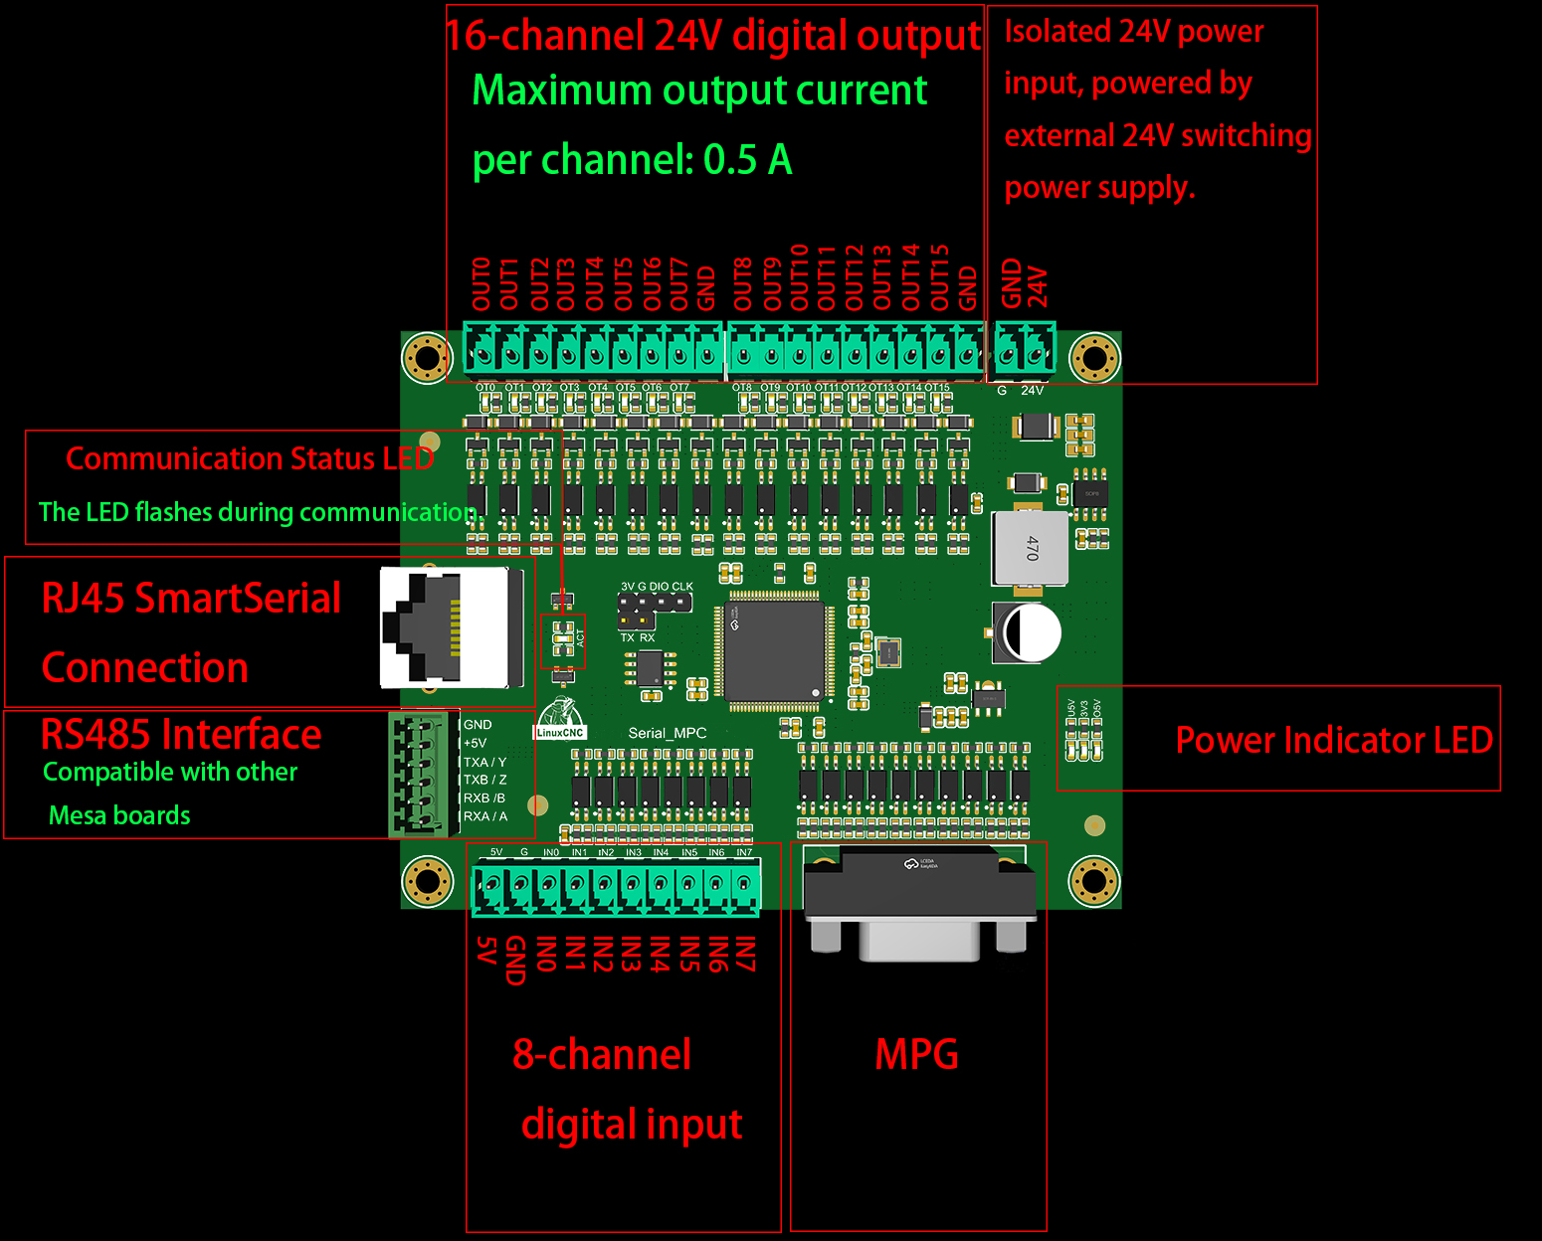

5.External Device Wiring Schematic

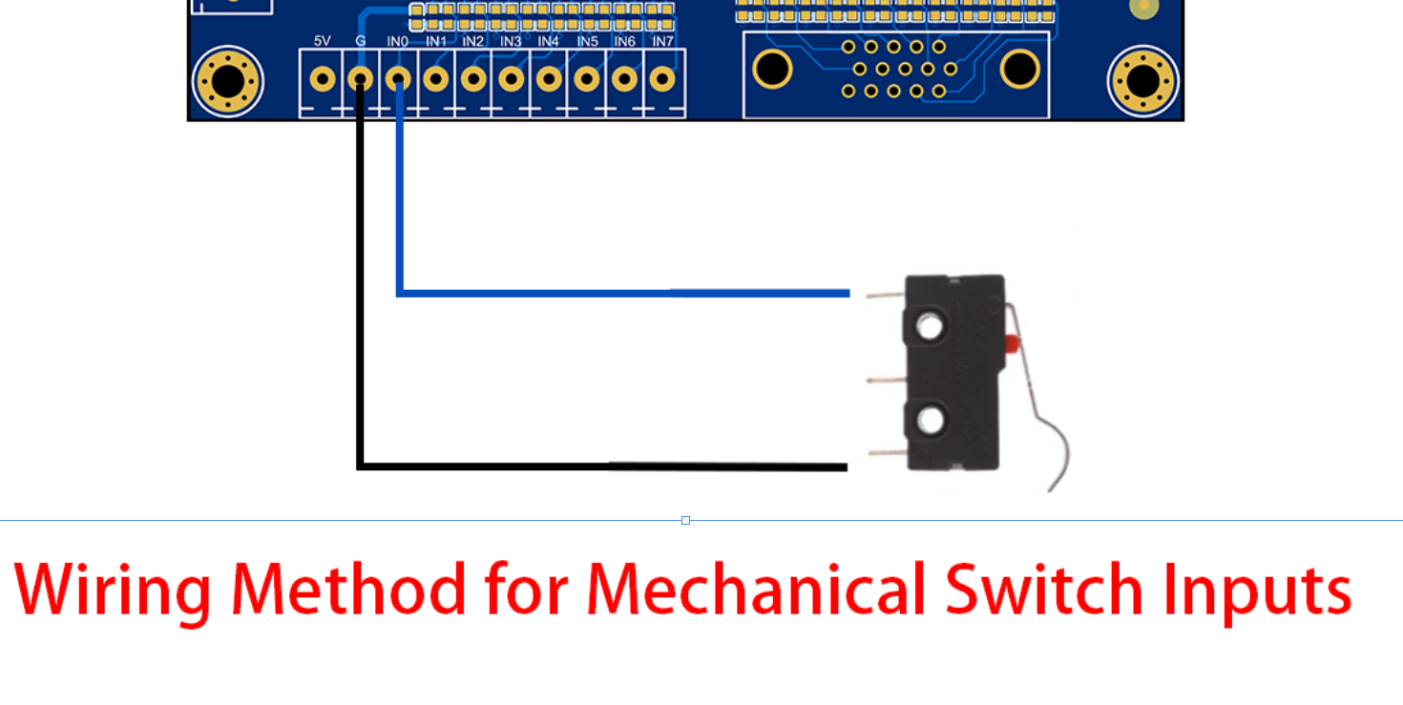

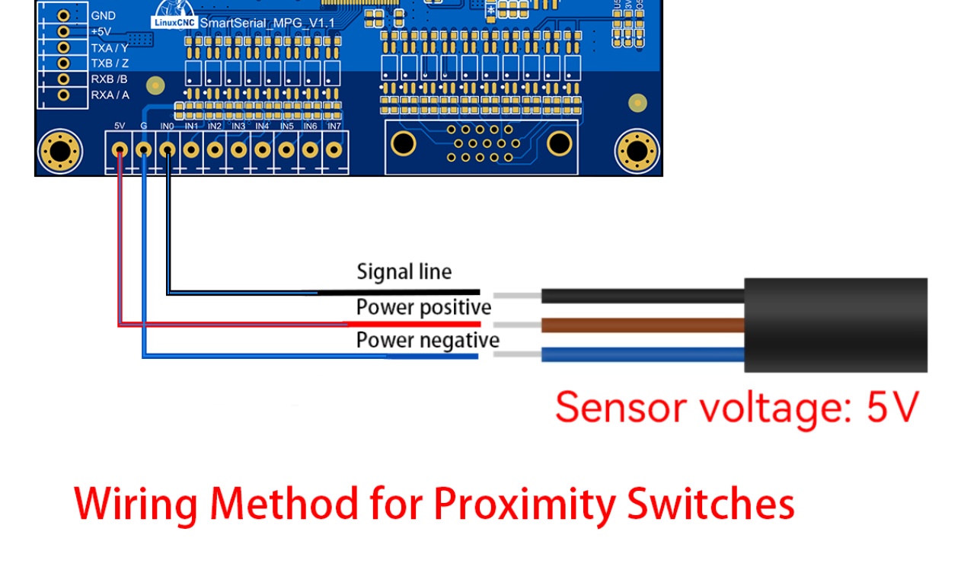
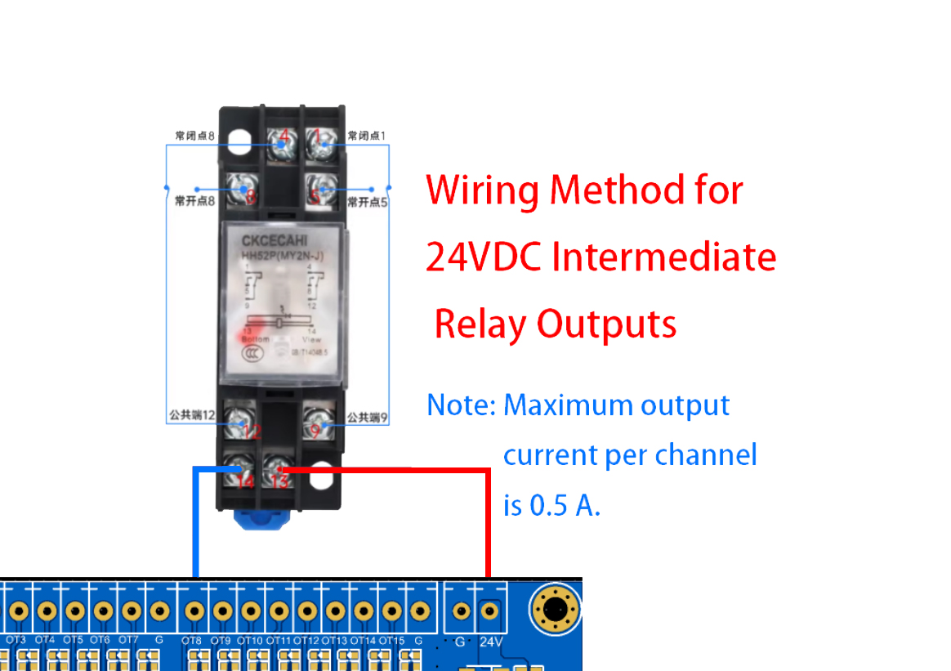

- RJ45 Interface Schematic Diagram
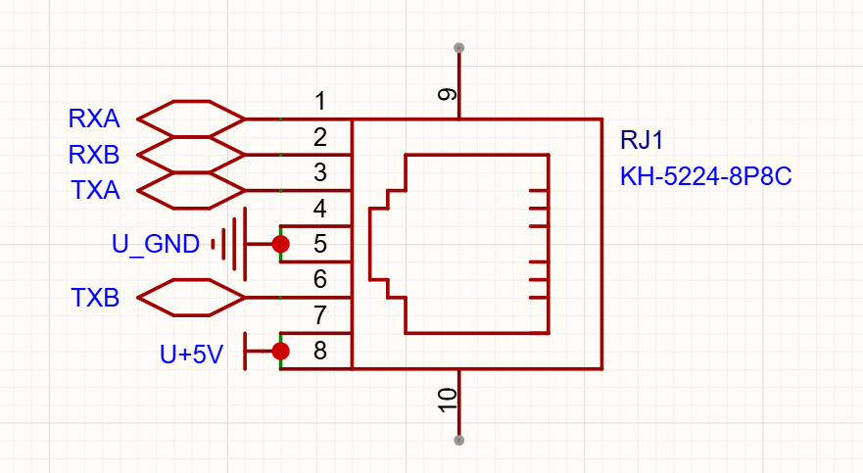

- MPG Pin Definition

